Raspberry Pi 400 GPIO Adapter
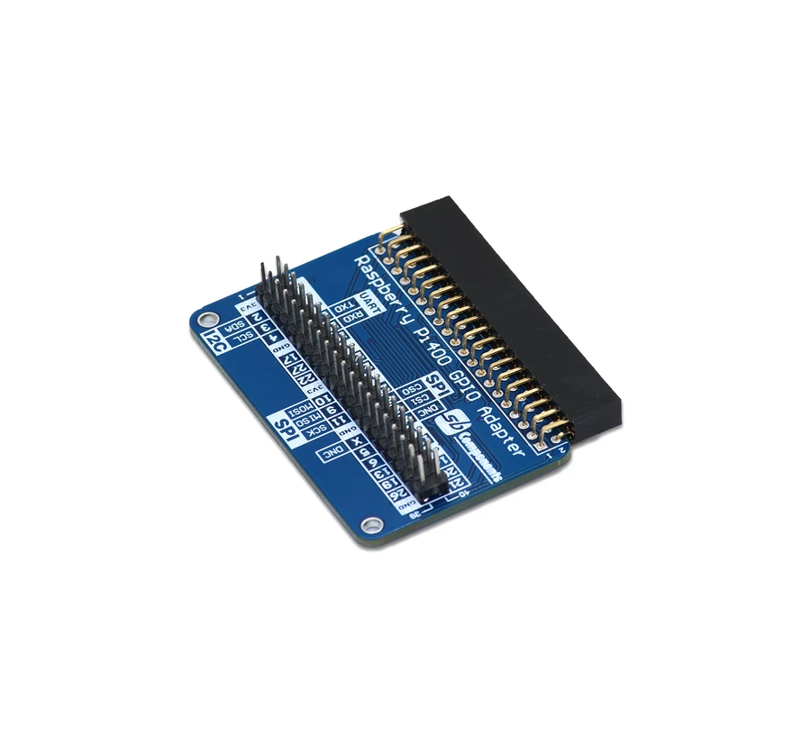

Contents

User Manual …………...……………….…………………………. 1
Introduction ……………………………….……………………….. 3
Features ……………………………………….……………………… 3
Specification ………………...……………...…………………….. 3
Hardware Dimension …………………………… …………….. 4
Installation Process …………………………...………………….5

Raspberry Pi 400 GPIO Adapter

Introduction

Raspberry Pi GPIO Adapter is a new I/O expansion kit technological device built with 2 x 20 pins headers designed for Raspberry Pi 400. SB Components developed a Raspberry Pi GPIO header extension to provide a way to connect any type of HAT with Raspberry Pi 400.

Features
- Female Header Connector for Raspberry Pi 400
- Male Header Connector for HAT
- Easy to Interface
- Compatible with Raspberry Pi 400
- Compatible with any Raspberry Pi HAT/SHIELD

Specification

- Connector - Female Header
- Connector for HAT - Male Header
- Compatible - Raspberry Pi 400
- Compatibility - Any Raspberry Pi HAT/SHIELD

Hardware Dimension

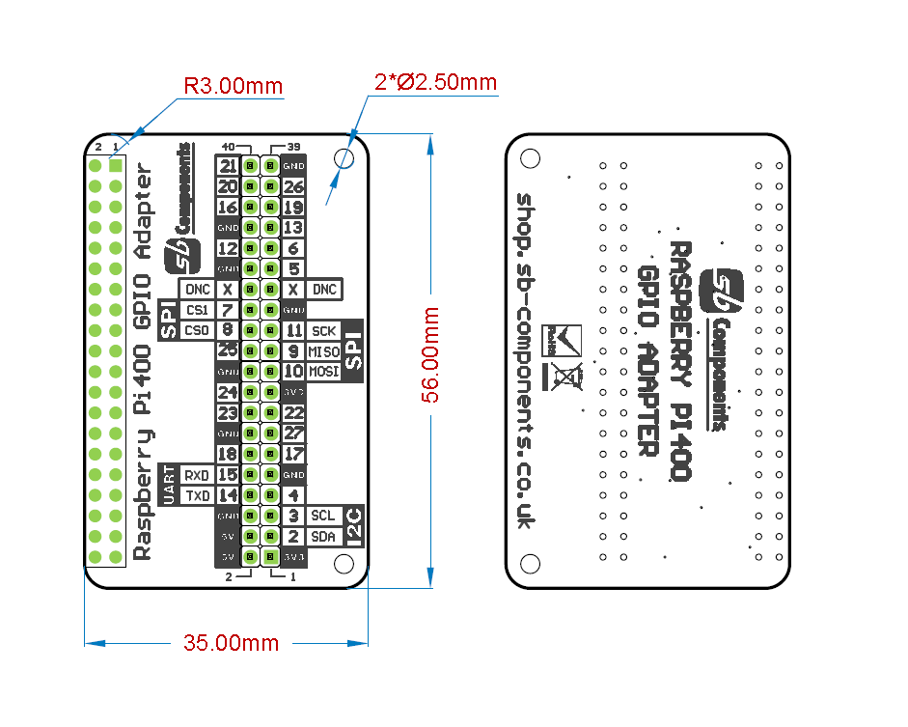

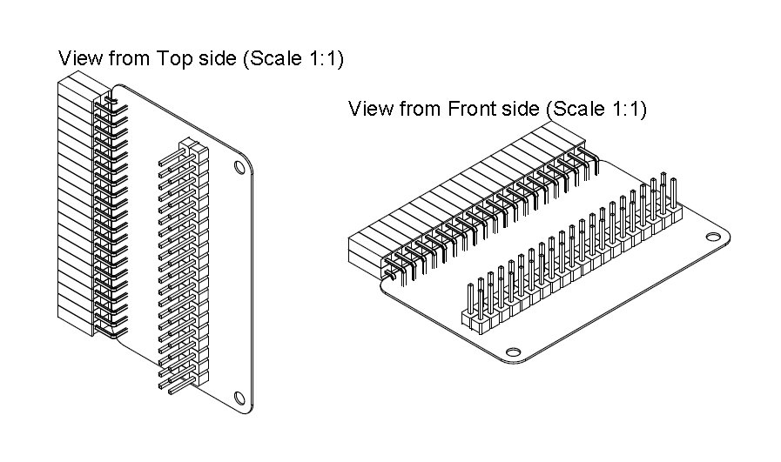

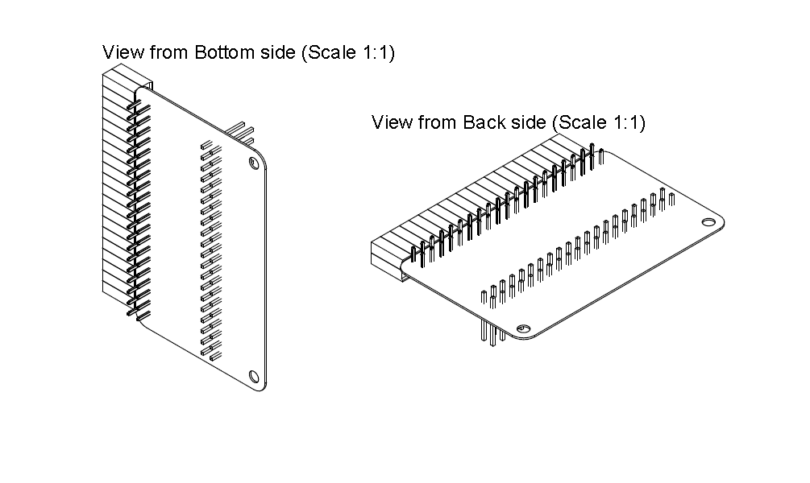
Installation Process
- Take Raspberry Pi 400 GPIO Adapter

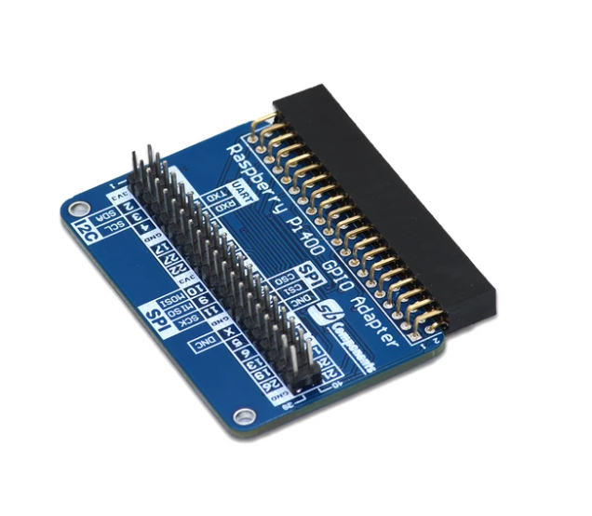

- Stack Raspberry Pi 400 GPIO Adapter on 40 pins Male GPIO header of Raspberry Pi 400 as shown in picture below.
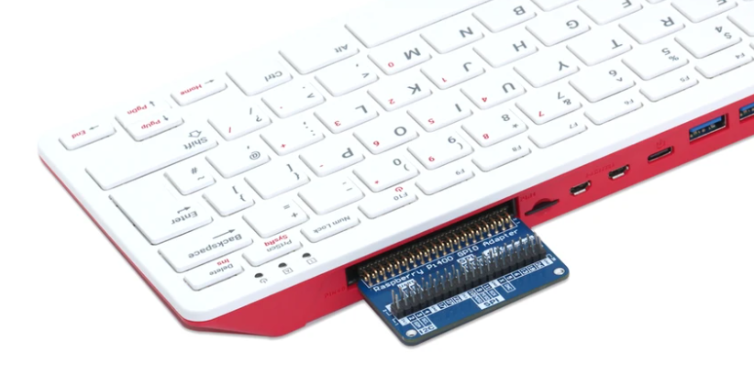
- Now you can connect any Raspberry Pi 40 pins compatible with HAT, peripherals and breadboard circuits as shown in the below image.


